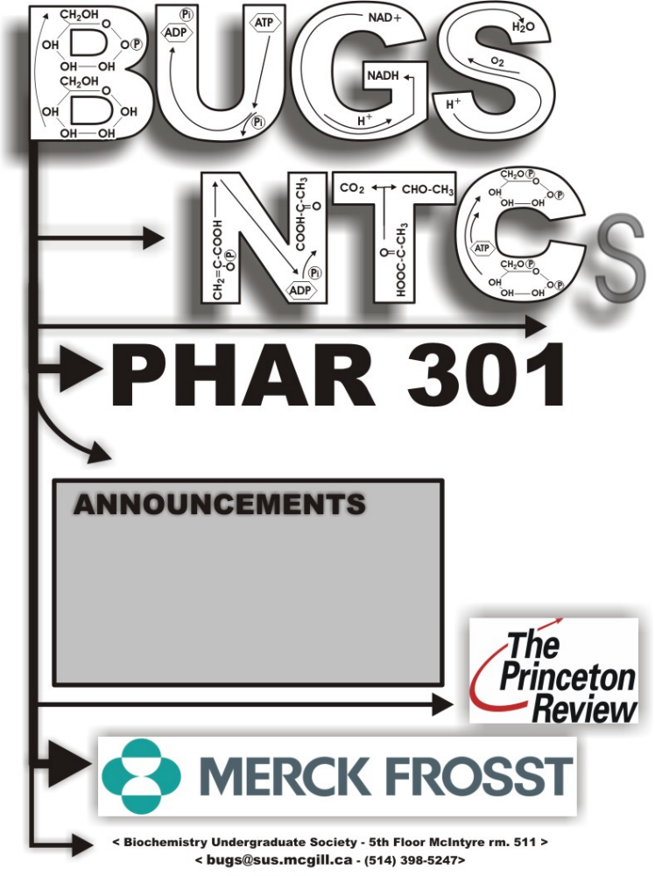

All Lectures given by:
Dr Paul Clarke
SET #4
Lectures 10-11
- Stay Tuned for more info on upcoming events!
- Make sure to activate you Athena account in order to access up to date information on the status of your NTCs

Tuesday, February 6, 2007.

Dr. Clarke – Lecture #10

Parkinson’s Disease

Drugs to know by name:
- L-Dopa + carbidopa = SinemetTM
- bromocriptine
- selegiline = deprenyl

Terms to know:
- substantia nigra
- striatum = caudate-putamen
- nigrostriatal
- bradykinesia

Readings: Brody textbook 4th edition Chapter 21
  - omit section on Alzheimer’s disease
  - do not memorize Table 21-1 (unimportant)

Note: palsy = paralysis

Main Symptoms of Parkinson’s Disease
- Parkinson’s symptoms include: rigidity (stooped posture), shuffling gait (walk), pill rolling tremor (as if rolling a pill in their fingers), bradykinesia (slow movement).
- Very much associated with postural problems – its is largely a disease of the elderly

Interesting fact – handwriting tends to get smaller when afflicted with the disease!

- typical mask-like face of PD patients

** 80% of PD is idiopathic (arising spontaneously or from an obscure or unknown cause) **

- There is a few rare cases of early onset of Parkinson’s disease (clearly genetic) - it is very sad because the prognosis is not good at all. These children are impaired from a very early age and decline rapidly. These cases are often linked to incest. It is most common in Japan (most likely due to some gene they are carrying).

Environmental Factors in PD

- Prevalence of PD in different hydrographic areas

- 1st major study done here in Quebec

- idea was that there is something in the environment that we’re expose to that gives us PD
  - divide Montreal region into nine hydrographic areas
  - knew the prevalence of Parkinson’s disease in each area
  - tried to find something that would correlate with it
  - found that the use of insecticides/herbicides/pesticides correlated with PD!

- We must remember though that correlation does not imply causation! However, we must remember that the great majority of PD cases do NOT have a significant genetic component – therefore the trigger must be environmental

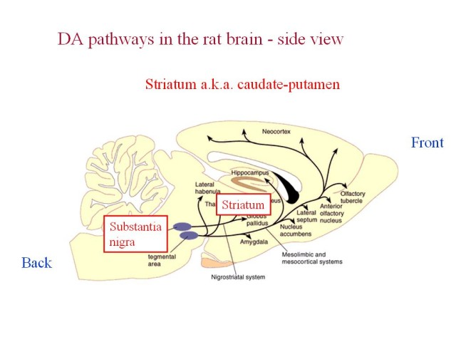
With PD patients, there is quite widespread damage in the brain but the greatest damage occurs to the nigrostriatal dopamine system– this is a group of cells that have their cell bodies in the substantia nigra (Latin for ‘black substance’).
- These dopamine neurons project up to another part of the brain called the striatum or caudate-putamen
- If you cut up the brain of a dead PD patient, what you see is there is a loss of dopamine cells
- In a normal person, dopamine cells accumulate a substance called neuromelanin (it makes the dopamine cells visible) – you therefore see dark bands in brain slices, which are thousands and thousands of dopamine cells. In a PD brain, we see very little of this dark pigmentation.
  - It is not just that dopamine cells have stopped making this black substance – they have actually DIED
  - In PD, you have a gradually dying of dopamine cells until clinical symptoms start to emerge

Dopamine cells are part of a larger network within the basal ganglia so that dopamine is just one important link in a network which controls the relationship between sensory input and behavioral output.

Nigrostriatal DA neurons die in PD

- The nigrostriatal pathway that dies preferentially in PD.

-We are ALL losing dopamine cells – on average, 3-5% of our dopamine cells die per decade

nigrostriatal pathway

Substantia nigra---------------------------------------→ striatum

-Clinical symptoms are not seen until ~70-80% loss of striatal DA occurs

The nigrostriatal system is needed for reacting to stimuli
  - 6-OHDA (close analog of dopamine) administered into the left and right substantia nigra of rats in an experiment (to model PD)
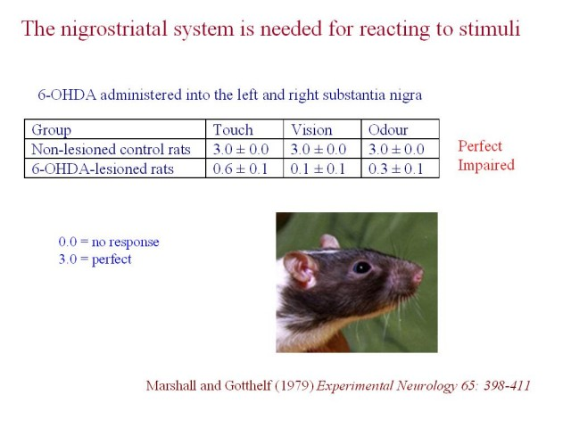
    - it gets into dopamine neurons because dopamine neurons express the dopamine transporter (to pump DA back into terminal) – 6-OHDA will be taken up by the DA cells; it will have toxic effects that will kill the DA cells in the substantia nigra
  - Animals, a few days after being administer 6-OHDA (and DA cells had died) were tested behaviorally. They were placed on a platform and then various stimuli were brought up to there face (either visual, tactile or olfactory)
    - A normal animal will orient towards the stimuli

  - We can see from the results that rats lesioned with the compound will not react to touch, vision or odour stimuli, vision stimuli being the worst. The group above it is the control.

Striatum: where cerebral cortex inputs meet dopamine
- DA terminals are in the striatum
- The striatum also receives a large input from the cerebral cortex carrying sensory information
- Dopamine enables sensorimotor integration in the striatum
  - Basically, without dopamine, sensory input does not yield motor output. This is also evident with the rat experiment just explained above.

Does DA loss produce a motor or sensory deficit?
  - Rat injected stereotaxically on one side of the brain with 6-OHDA. We want to know if this is a sensory or a motor problem. So we injected a rat only on one side with the compound. One side reacts perfectly to stimuli. Also, the side injected reacts to stimuli as we can see, since the rat moves the contralateral leg from the good side.
    - In a video showed in class, the rat (with a lesion on the right side of his brain) is able to move his right leg (and fell with his left side – whiskers)
    - He can react to whiskers on both sides; what he can’t do is move his left forepaw – therefore it is a MOTOR PROBLEM (motor impairment is OPPOSITE to the side of the lesion)

A patient comes in with acute psychosis with catatonia? Or PD?
  - Patient mute and immobile
  - Psychiatrist thinks it looks like acute psychosis with catatonia (catatonia = when you can adopt any position and keep it for hours – unusual form of schizophrenia)
  - Initially given a DA receptor blocker (medication used to treat schizophrenia – anti-psychotic) – but patient got worse!
  - Opiate analogue found in blood– side product MPTP – patient was a drug addict.
  - One doctor said it was PD….no one believed him since the patient was only 25 years old.
  - Found that the patient and six others with similar symptoms were all using MPTP.
  - A test is to check levels of DA metabolite HVA in the CSF: if it is present in normal or higher amounts you know this is not PD, since there should be a deficit of dopamine metabolite. If it is schizophrenia, the metabolite would be abnormally high, since the disease is associated with high DA and DA metabolite levels.
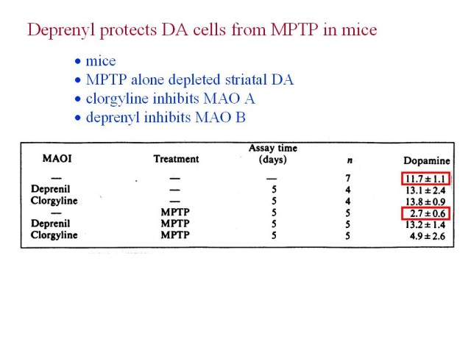
    - In all the patients, the HBA levels were LOW, indicating PD.

MPTP is lipophilic; it gets through membranes and the blood-brain barrier. When you give it to mice, it produces DA cell death within a few days.
- However, MPTP does not kill DA cells in culture!
  - MPTP is a substrate for MAO (in particular, MAO B)
  - Experiment: 6 groups of mice
  - Controls have normal dopamine, and mice given just MPTP alone have much lower DA levels
  - If you give Deprenyl it protects DA cells from MPTP in mice – this therefore implicates MAO B in the toxic effect of MPTP

- MPTP is chewed up by MAO B and turned into MPP⁺. MAO B is found in astrocytes (glial cell) in the brain. The metabolite MPP⁺ escapes the astrocytes and selectively kills DA neurons in the substantia nigra. MPP⁺ doesn’t kill the astrocyte where it was formed (why? not known), and preferentially kills DA cells.

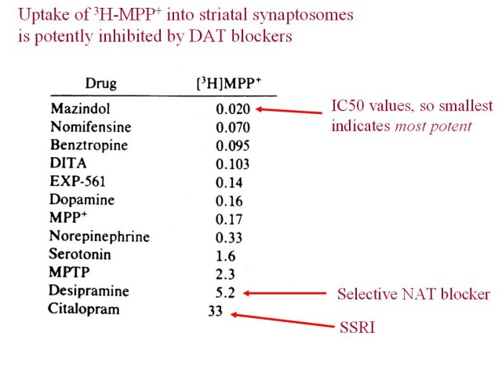
Uptake of H-MPP⁺ into striatal synaptosomes is potently inhibited by DAT blockers:

  - The uptake of ³H-MPP⁺ can be potently inhibited by drugs at the TOP of this list – these are drugs that block the DA transporter
  - This suggests that MPP⁺ is taken up by the DAT

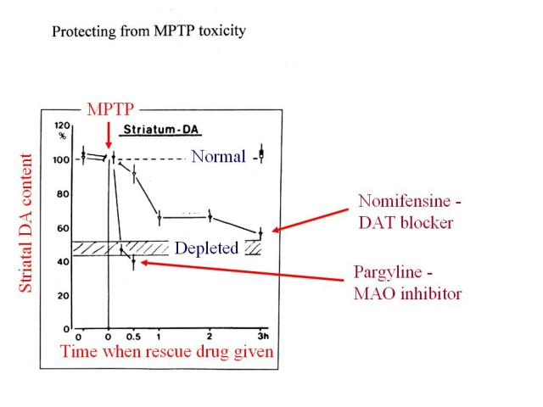
Protecting from MTPT toxicity: pargyline & nomifensine

How much time after taking MPTP can you still take pargyline (MAO inhibitor, similar to deprenyl) and be safe?
- MPTP injection, without any other drug, depletes DA levels by about half
- If you take pargyline before MPTP, you lose no DA cells. If you take it instantaneously after injecting MPTP, you still lose no DA cells. However, if you give it about ½ hour after MPTP, you completely lose the protective effect.
- Since pargyline gets into the brain quickly after injection, this implies that the conversion of MPTP to MPP⁺ by MAO occurs FAST (shorter than 30 minutes!)

Question: What about take-up of MPP⁺ into the dopamine cells – does this occur fast?
- You can give nomifensine (DAT blocker) a little later after taking MPTP – half an hour, and still be safe for the most part. Therefore, this is a slower process.

Question: How does MPP⁺ kill DA cells?
- It gets into the DA cells and inhibits the electron transport chain – this prevents the production of ATP and the DA cell run out of energy (producing a chain of bad things)

Question in class: if you give 6-OHDA, the toxin from before, and take either of the two rescue drugs, will the patient be safe?
  - Since MPTP is a pro-toxin, it needs the MAO to become an active toxin. 6-OHDA is not a pro-toxin (it’s a toxin in itself), and therefore MAOI wouldn’t do anything. However with DAT inhibitors, 6-OHDA would not be transported into the DA cells, therefore protecting you.

Paraquat is an analog of MPP+ that is found in the environment; it is an insecticide.
- It has two positive charges on it, as opposed to one in MPP+; therefore, since it is more charged, it will have a harder time to get through the blood-brain barrier
- If you give large enough doses in animals however, it gets into the brain and, like MPTP, results in PD symptoms

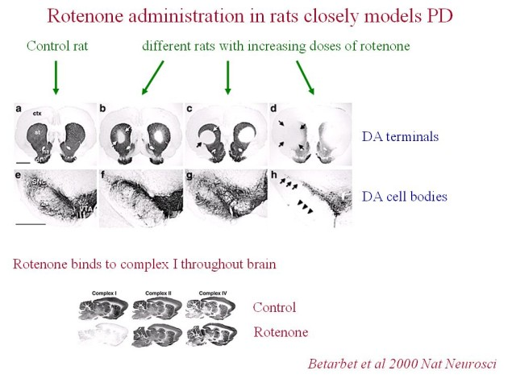
Rotenone administration in rats closely models PD

- causes degradation of both the DA cells and the DA terminals
- figure at left: top panel is the striatum, bottom panel shows the substantia nigra
- rotenone causes a dose-dependent lesion
- rotenone gets through membranes very easily; it does NOT go through the DAT.
  - Given systemically, it probably get into every cell in the brain!
- Rotenone inhibits complex I of the ETC
- Although it inhibits complex I in all cells and not just DA cells, it SELECTIVELY kills dopamine cells in the brain. This tells us that dopamine cells are especially susceptible to the toxic effect of inhibiting the ETC (there is something particularly vulnerable about DA cells).
- Rotenone has, at the behavioral level, been shown to produce immobility and tremor.
- Rotenone can be bought at the hardware store, it is used as a pesticide and a “piscicide”. People with catfish in their lakes will spray the actual lake with rotenone. This is because catfish (which anglers do not like) are more susceptible to the toxin than trout and other valuable fish.

- Most or all of the drugs that we have to treat PD work at the symptomatic intervention level – that is, they make the symptoms less but they don’t stop the DA cells from dying

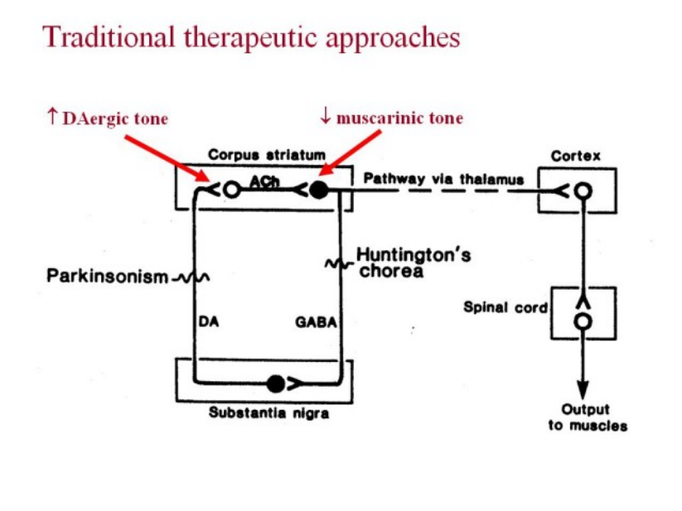

- Traditional therapeutic approaches (still used today) include to either increase DA tone or to reduce muscarinic cholinergic tone by blocking muscarinic receptors in the striatum.

There are various ways you could treat dopamine to increase DA tone:
- You can’t just inject dopamine since it is broken down in the bloodstream; therefore, the precursor, L-DOPA, is used
  - L-dopa is more stable and enough gets into the brain to make DA
- We can inhibit MAO so that whatever DA is formed from L-dopa in a PD patient is not broken down as fast
- Give DA agonists that act post-synaptically to replace the DA that you’ve lost

- L-DOPA is taken orally, mixed with food and taken up through an amino acid transporter. It is competing with proteins that you have broken down into amino acids in order to get into the bloodstream. (Therefore if you have a big meal with a lot of protein, your L-DOPA uptake is less).

- There is an enzyme, DOPA decarboxylase (DDC) in the periphery, also known as aromatic amino acid decarboxylase (AAADC)
- L-DOPA, which is absorbed into the bloodstream, is converted by this enzyme into dopamine, thence to noradrenaline and adrenaline, and these can produce nausea and changes in blood pressure (increase or decrease).

- If you just take L-DOPA, you get a lot broken down in the gut wall, you get a lot broken down by DOPA decarboxylase; only 1% of your L-DOPA will get into the brain!
- Therefore you don’t give L-DOPA by itself; you give it with a drug that inhibits the peripheral decarboxylase so that you have less transformation of L-DOPA in the periphery

Peripheral and central metabolism of L-DOPA

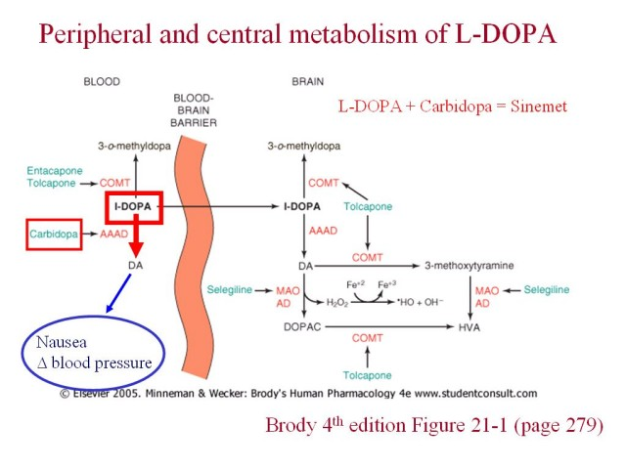
- If given on its own, a lot of L-DOPA would be converted into DA, causing many bad things to happen (nausea, change in blood pressure)
- Therefore we block this enzymatic pathway with an enzyme called carbidopa (it doesn’t get into brain so it only acts peripherally)
- L-DOPA + carbidopa = SINEMET
- Now more L-DOPA gets converted to DA in the brain
- There is MAO in the brain which converts DA into a metabolite; we don’t wants this, so we give another drug called selegiline = deprenyl

Where is L-DOPA converted to DA?
- In a normal subject, L-DOPA is converted into DA mainly in DA terminals
- In a late stage PD patient, most of DA terminals have died; however, L-DOPA can be converted into DA not only in DA terminals but also other non-dopaminergic cells.
  - The enzyme, aromatic amino acid decarboxylase (=DOPA decarboxylase), is present not only at DA terminals but also other types of cells
  - In late stage PD patient, you have post-synaptic supersensitivity (more receptors) and you have L-DOPA being converted into DA at non DA terminal cells – this is good in a sense but not ideal because:
    - In a normal brain, you have action potentials releasing DA when an action potential arrives; DA cells have a particular ‘rhythm’ about them - maybe the release of DA is temporally coded?
    - In late stage PD patient, what you have is L-DOPA being constantly made from L-DOPA with no rhythmicity to it - therefore it is likely that something is being lost

Problems with L-DOPA and SINEMET* (see also Brody’s 4th ed. Chapter 21, page 282)
  - less and less useful with time such that after 5 years it doesn’t do much for the patient
  - dyskinesia/dose window – with chronic treatment, the dose window gets smaller (harder to find the right dose); if you give to much you get dyskinesia (movement disorder). If you give too little, then the patient becomes rigid and shows PD symptoms
  - on-off symptoms – could be walking along and suddenly you freeze (off symptom) even if your L-DOPA levels are not low
  - psychiatric problems – if you increase the concentration of L-DOPA too much, can get hallucinations
  - pharmacokinetics (uptake, t_{1/2} )
    - remember that the drug uses the same terminal as amino acids do for absorption; therefore, could be impaired with very large protein saturated meals.
    - The t_{1/2} of L-DOPA is short (~3 hours)
  - neurotoxic?

Side Note: there is quite a big placebo effect in PD!

Chronic L-DOPA does not appear to harm DA cells

- When DA is metabolized, free radicals form!
- If there are too many free radicals formed, then potentially they could kill DA cells. Therefore, if L-DOPA makes DA that makes free radicals, could see how L-DOPA can be potentially toxic in human cells
- Rats given 6-OHDA to produce a moderate or severe loss of DA cells.
  - Chronic L-DOPA + carbidopa vs. untreated
    - Expectation was that the L-DOPA might make the DA cells die more readily – however there was no effect of L-DOPA in this experiment
    - Therefore this experiment suggests that if L-DOPA does have a toxic effect that it is quite small
  - Image DA cell body area using antibody that recognizes tyrosine hydroxylase. No harm done to them, they still show up as DA cells.

DA agonists can alleviate motor deficits in animal studies
  - Monkeys given MPTP previously
  - The monkeys have difficulty picking up food, and are uncoordinated.
  - Normal locomotion on a simple scale is 60.
  - With MPTP locomotion drops to 10.
  - Giving a rescue drug (DA agonist) brings it back to 60.

Directly acting DA receptor agonists: e.g. Bromocryptine

Theoretical advantages over L-DOPA
- Should work in complete absence of DA (therefore works even on late stage PD patients)
- Less DA release so fewer oxyradicals
- Longer half-life 7 hours, rather than 3 hours of L-DOPA.
- Clinical experience
- Less effective than L-DOPA.
- Useful adjunct (taken with OTHER medications such as L-DOPA).
- It is sometimes used to avoid giving L-DOPA right away (since L-DOPA only works for a few years). Therefore, PD patients are sometimes put on bromocryptine when the symptoms are not so bad so as to postpone the use of L-DOPA until the symptoms become very bad and the more effective drug, L-DOPA, is needed – buys time.
- Adverse effects (nausea, postural hypotension, CNS effects, hallucinations)
  - DA receptor agonists may increase pathological gambling!

Deprenyl seems to slow the progression of PD
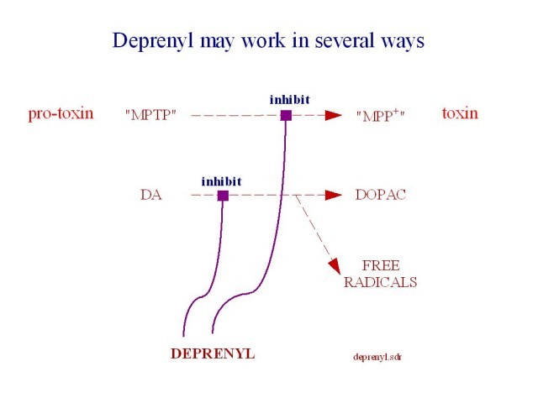
- Deprenyl seems to delay the point at which the PD patients have to go on L-DOPA
  - Claim was made that deprenyl reduces the rate at which DA cells die – the claim is it is acting as a neuroprotective agent
- Theoretically, deprenyl may work in several ways. We do not know whether or not it is neuroprotective in humans. Is it purely producing a simple beneficial effect? We have no idea!

- Deprenyl shown to be neuroprotective in rats, but not shown how in humans.
- Inhibition of MPTP converting into the toxin MPP⁺
- Inhibition of free radical formation via DA

metabolism…free radicals are degenerative.

- If it is neuroprotective, you should be able to washout the drug, and the patient should have a long term benefit since you’ve saved so many DA cells from previous treatment with deprenyl. Results were not clear, because people could not agree how long the washout time was for the drug. Couldn’t tell if it was benefits from having the drug there still (poorly washed out) or if it was actually gone and the benefits remained.

Monoamine oxidase B concentration and cigarette smoking:
- Smokers are ½ as likely as non-smokers to develop PD
  - Smokers have a mild decrease in MAO B activity in the brain (30-40%). This could be important, since if there are one or more environmental pro-toxins like MPTP that require conversion by MAO in order to kill DA cells, smokers would make less toxin!

Recent developments in areas:
  - Drugs to promote neurogenesis
    - Normally in an adult brain, nerve cells (neurons) do not divide (they are post-mitotic). This is not entirely true. There are cells in the brain ready to divide and make neurons.
    - Drug found that encourages cells to divide and make neurons – even DA ones!
  - Fetal Substantia Nigra grafts
  - Xenografts
  - Viral factors/trophic factors
  - Stem cell

- Deep brain stimulation surgery: electrodes in the brain stimulate parts of the brain - can have a dramatic improvement of symptoms…might be used more in the future.

- D3-receptor agonist partially restores tyrosine hydroxylase immunolabeling in the DA-denervated substantia nigra
- D3-receptor agonist that promotes neurogenesis in rats.
- Tyrosine hydroxylase = DA cell marker (only found in DA cells in this area)

They lesioned rat brain with 6-OHDA, and then they added a chronic D3 agonist –and after 8 weeks, they found that many DA cells were regenerated in the substantia nigra.
- However, this finding alone does not tell us whether these DA cells are functional or whether they even project to the striatum
  - To check for this, retrograde tracer (dye) was injected into the striatum – taken up by DA terminals and taken back to DA cells in the substantia nigra
  - In animals treated with the D3 agonist, there is substantial labeling in the substantia nigra, proving that the cells that were made thanks to the drug do indeed project to the striatum
    - And it produces a behavioral benefit! – Rats with lesion have rotational behavior in which they run around in circles. This rotational behavior was much reduced in animals that received the drug

- Glial cell line-derived neurotrophic factor (GDNF)
- GDNF is a trophic (growth) factor
- GDNF promotes survival of DA cells
- Can be delivered to striatum via:
  - External pump + catheter into striatum OR
  - Viral vector injected into striatum OR
  - Encapsulated engineered cells into striatum
- In an experiment with 6-OHDA lesioned monkeys, added GDNF vs. a control (saline) → GDNF was found to regenerate many of the already damaged DA neurons.

Thursday, February 8th 2007
Dr. Paul Clarke

Anti-anxiety drugs

Drugs (etc.) to know by name
- diazepam= Valium
- buspirone (a partial 5-HT1A receptor agonist)
- propranolol (beta blocker)
- benzodiazepine (BZ)
- anxiolytic= anxiety-reducing

Reading: Chapter 24 for anxiety and Chapter 10 for propranolol (pp.134-135 only)

Aims of this lecture
- What are the main types of anxiety?
- To what extent are they treatable with drugs?
- What is the best treatment currently?
- Do all types of anxiety respond the same to all drugs?
- Is there a difference between “mental” and “physical” anxiety?
- How do the main anxiolytic drugs work?
- What use(s) can animal models serve?
- Future treatments?

What is anxiety?
- can be good and bad, a little bit is good (adaptive) but can become pathological
- quite common (real clinical anxiety, not just talking about people who become a bit anxious before an exam, for example)
- In Britain, 14% take anxiolytics regularly and in the USA, 10% have taken anxiolytics
- Main types of anxiety disorder: generalized anxiety disorder, panis disorder and phobias
- Will concentrate on generalized anxiety disorder this class

Main types of anziety disorders

Generalized anxiety disorder
- constant worry
- lasts for months (must last at least 6 months to be clinically characterized)
- muscle tension, autonomic arousal, vigilance
- feel on edge all the time

Panic disorder
- episodic
- recurrent
- brief (minutes not hours)
- intense, feelings of doom and dread (e.g.: fear heart will stop beating)
- extreme fear and stress symptoms
- linked to depression? Most of the drugs that are effective for panic disorder are anti-depressives, and panic disorder and depression often occur in same families (likely linked genes)

Phobias
- social (e.g.: speaking in public)
- specific (e.g. snakes, exams)

Drug treatments for anxiety

Generalized anxiety disorder
- benzodiazepines (e.g.: Valium)
- Beta blockers (e.g.: propranolol) if somatic- feel anxiety mostly as symptoms in body rather than in mind (blocks B adrenergic receptors in periphery)
- Buspirone (5-HT1A partial agonist), more recent, some advantages over benzodiazepines
Panic disorder
- antidepressants
- one particular BZ, unusual benzodiazepine, thought to have secondary action as antidepressant, rather than working via GABA_{A} receptors
Phobias
- specific phobias- no drugs
- social phobias- Beta blockers

For all these disorders… drugs are not a cure (only treat symptoms) and drugs are not enough (e.g.: also psychological support)

Anxiety and depression often go together; suggesting common brain mechanisms.

Generalized anxiety- Drug evolution
- ethanol; antiquity
- barbiturates; 1900s, sedative, dangerous, easy to overdose, respiratory depression, easily kill yourself, not good drugs, hardly used for anxiety now
- meprobamate; 1955, was a WWII refugee from Czechoslovakia (Frank Berger); trying to find drugs to treat infections that were resistant to penicillin, tried a number of drugs, one that they tried, mice seemed to go limp. Thought maybe having effect on musculature; gave to humans and didn’t feel as anxious. Made analogs and came across meprobamate. Claimed there was no sedation however once it was marketed, clear that it caused sedation. Good side: gave people idea that one day possible to make drug that would be purely anxiolytic.
- Benzodiazepines (BZs); 1960s, put drugs aside, did cleaning of lab, tested them and worked as anti-anxiety (Librium); start of “me too” benzodiazepines; chemical modifications, about 20 on market.
- Buspirone; 1980s, does not involve GABAa receptor

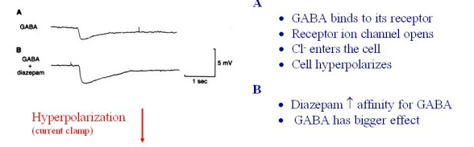

BZs enhance GABA-induced hyperpolarization

- demonstrate this in mouse spinal cord neurons in culture and record from them
- A: GABA alone
- B: add diazepam, makes the GABA effect bigger

Proved this further with receptor autoradiography; distribution of 3H-diazepam binding in rat brain resembles that of GABAa receptors
- probe section with a radio-ligand, triated diazepam
- red: a lot of binding, blue: very little
- see certain distribution
- do this also this another compound known to bind GABAa receptor and you see a similar but not identical distribution
- does this mean that diazepam is binding GABAa receptor? Does NOT prove it* but suggests that it might.
- *Might be that the type of cell that makes one type of receptor also make the other type

Must look at molecular level
- do this with competition binding study
- if have two drugs that bind to same site on a receptor, they will compete
- if you have one that is radioactive, you can reduce its binding by adding the other one (swamp it out by adding a lot of the other one); this is usually what happens however in this case, the opposite happened
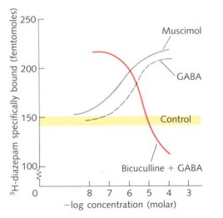

GABA increase 3H-diazepam binding! Did not reduce it as expected; had never been seen before. Two possibilities:
- either GABA is somehow revealing new sites to which diazepam can bind to (e.g.: force receptors to come up through cell membrane and be available for binding- increase density of surface receptors)
- GABA increasing affinity that diazepam has for its receptor
Increased affinity is the correct answer; use Scatchard Plot to see this; slope in line shows increase in affinity.

Benzodiazepines can increase GABA receptor function by making GABA bind more tightly to receptor; therefore GABA has greater effect for given concentration.

GABAa receptors act as digital switches
- three parameters describe their activity: probability of opening when it is in shut state, open time and conductance (current going through the ion channel)
- based on these three parameters, can do experiments where you give BZs, GABA or a combination.
- occupy two states: open or closed (can do patch-clamp studies to isolate individual receptors)

BZs increase the probability of GABA-induced channel openings, whereas barbiturates prolong them
- patch clamp permits recording of single GABAa receptors
- channel openings are shown by downward deflections
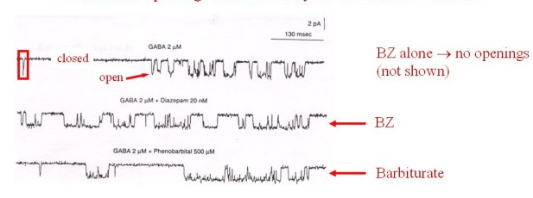
- when no agonist present ; very few openings
- when open, see downward deflection
- in presence of agonists; see opening
BZs are not agonists; do not work alone, instead they potentiate GABA's action
2nd panel: BZs increase the probability of channel openings
Barbiturates: increase time channel will be open

GABA receptor
- large molecule
- binding sites for different things
- BZs don’t bind at same site as GABA
- They do not compete for same binding site
- A drug that potentiates transmitter action by binding elsewhere on the receptor is called a positive allosteric modulator

BZ drugs differ much in terms of pharmacokinetics (see Brody pp.307-308)
- rapid brain entry then redistribution to periphery (a lot goes to brain right away since huge blood supply and then slowly leaks into the less well-perfused fat in the periphery). This redistribution process reduces the duration of action of diazepam when it is given intravenously.
- active metabolites
- binding to plasma proteins (diazepam: 99% is bound to proteins, forms reservoir that gradually releases diazepam, makes it last longer)
- enteropatic recycling (not know details, simply cycling of metabolites or parent drug from liver to gut then back out from portal vein to liver- some drugs will be trapped in cycle and slowly released, like reservoir, way body stores drug, drug lasts longr)

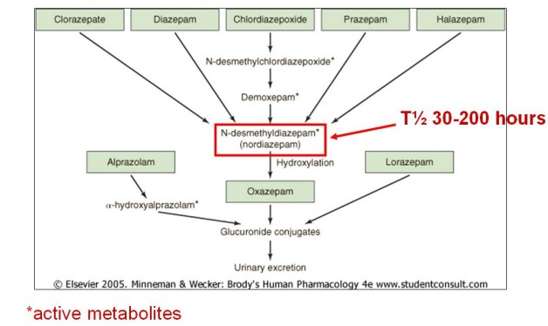

- half-life of metabolite could be longer than parent compound (and this metabolite can be pharmacologically active)
- to obtain a shorter-lasting drug, you want to avoid this nordiazepam, that’s why we see in lower boxes (below nordiazepam) some shorter lasting BZs

If you look at different BZs, you see that some are potent sedatives, muscle relaxants or anticonvulsants.
Some do a bit of each.
Diazepam: relax> sedative
Because of these differences, gives us hope to produce even more selective drugs.

Can we make better BZ drugs for anxiety?
Not all GABAa receptor subtypes are equally sensitive to BZs.
Sensitivity to BZs depends on the α and γ subunit
- recombinant GABAa receptors studied in oocytes (in frog eggs)
- mutations in mice (e.g.: knock out receptor subunit)

Frog egg experiment: expression in Xenopus oocytes
- get frogs to produce eggs (eggs don’t naturally make GABA receptors)
- introduce genetic material in egg
- egg starts to make proteins; subunits
- Oocytes expresses the proteins and if you are lucky the subunits come togther and you get functional GABA receptors
- You have a ready supply of one particular subtype of receptor
- Do electrophysiology studies
Can also mutate the receptor in a variety of ways in mice and see where particular compounds bind like GABA or diazepam(rational drug design is becoming possible)
(see ion channel in the middle)

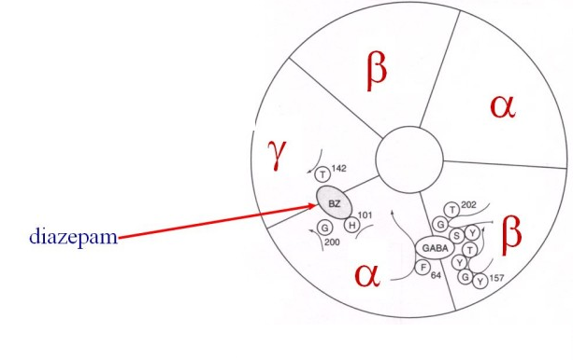

There are probably a large number of GABAa receptor subtypes (we do not know the number but there at least four that are sensitive to BZs)
- α subunits are differentially distributed in mouse brain (α1,α2,α3,α5)

Recent work has used mice with mutations
The anxiolytic action of diazepam is mediated by α2-containing GABAa receptors
- point mutation in α2-containing GABAa receptors
- these mutant receptors are insensitive to diazepam
- mice tested for anxiety
- will they venture into the light when given diazepam?
The experiment:
- wanted to find out which subunits were involved in BZs effects
- animal model in mice; test how anxious mouse is
- compared WT (wildtype; normal) with mice that had a mutation in α2-subunit
- this mutation was a very slight change in amino acid such that the receptors no longer reacted to BZs
- so question: is diazepam binding to α2 in order to reduce anxiety? If that’s the case, if stop diazepam binding, diazepam should no longer be anxiolytic
- mice have a tendency to explore but they are timid creatures and do not like going into the light
- normal animal: spend most of its time in the dark, once you give it Valium, it spends more time in the light
- mutated mouse: mouse stays in the dark, diazepam no longer has its anxiolytic effect
- tests done by Merck in England; then concentrated on making drugs selective for that receptor subtype. Made drug that was anxiolytic without being sedative (so far just tested in animals).

Benzodiazepines and anxiety- summary
- mainstay of short-term therapy (not take for more than ~ 8 weeks)
- around 20 BZs are in use
- major pharmacokinetic differences between them (T1/2 plasma: midazolam ~ 2h, diazepam>24h)
- unwanted effects: sedation- could be good if you want sedation but most of time you don’t - people tend to become tolerant to sedative effect but retain anxiolytic effect (etc.), O/D (especially with alcohol), dependence (mainly with history of drug abuse), withdrawal (rebound anxiety, might even have convulsions, etc)- BZs that come out of body more slowly have a milder withdrawal syndrome
- BZ antagonists (binds to same site as BZ and prevents effect of BZ); good to have when someone overdoses on BZ, e.g.: Flumazenil
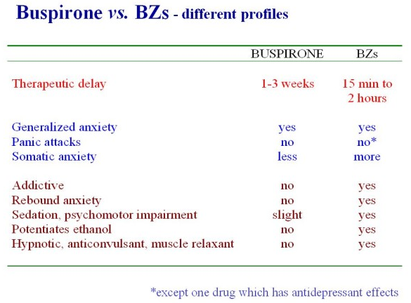

Buspirone
- developed after BZs
- has numerous differences; unlike BZs, buspirone takes 1-3 weeks to have an effect (like anti-depressants)
- (see table)

Busprione is a 5-HT agonist

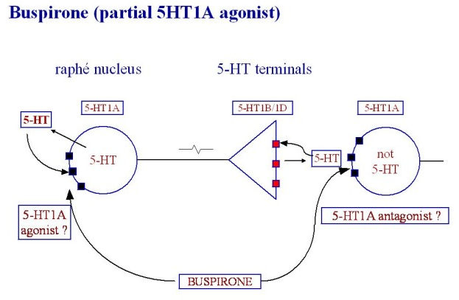

- 5HT1A receptors: autoreceptors on 5-HT cell bodies and also post-synaptic to the 5-HT terminal
- Buspirone: do not really know how it affects the system. For sure it will be working somato-dendritically and post-synaptically, but do not know if it is working as an antagonist or agonist (in absence of 5-HT will act as agonist, in presence of 5-HT, may act as antagonists; in the brain, we don’t know how much the “5-HT tone” is towards the left (i.e. dendritic) or the right (i.e. postsynaptic) so we do not know if buspirone is increasing or decreasing 5-HT transmission)

Moving on now to third class of drugs…

β blockers- Propranolol (a classic β blocker)
Endogenous agonists at β adrenergic receptors: NA and adrenaline
- originalyl made to reduce high blood pressure
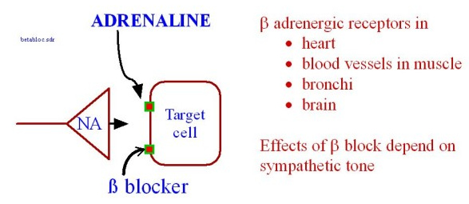

- the effects will depend on how much of the endogenous ligand you have present
- will be most effective in cases where you have high sympathetic arousal like anxiety (e.g.: if you have a lot of adrenaline going around in your system, propranolol will have a big effect; will counter the effect of adrenaline)

Dr. Clarke proposed a study: testing the affects of a β blocker while playing the trumpet.
- one person given a β blocker, the other not; both trumpet players
- students must rate the quality of the performance (students do not know who took the β blocker)
- play better with β blocker
Problems with experiment?Things we can change? Took answers from students:
- one player might be less anxious than the other if for example, more use to being in front of an audience
- have a before-after comparison
- have two trials; during the second trial, the other player will take the pill (i.e. do a cross-over design)
- do double-blind (person who took it doesn’t know they did, e.g. one gets a placebo, and neither do the evaluators)

A real experiment done by the Juilliard School of Music: Effect of β blockade and β stimulation on stage fright
- each subject receive propanolol and placebo
- random order, double blind
- tested once in each drug condition
- students were then tested an additional (third) time with a beta agonist
Measures
- electrocardiogram
- blood pressure
- stage fright questionnaire
- quality of performance

Results:
- compare Placebo vs. Beta blockade for pulse during performance: much higher in placebo
- post-performance blood pressure: no difference between placebo and Beta blockade- not surprising since the “anxiety situation” has passed
- maximum pulse during performance: beta stimulation vs. placebo; not significant difference- surprising; might be because the beta stimulation trial was the third and last one so by then the students already had less anxiety.

Three main principals of experimental design:
- Control (e.g. placebo condition, blind evaluation)
- Randomisation (randomly allocate subjects to conditions)
- Replication (use several or many subjects per condition)

Results of experiment: Judges overwhelmingly thought that the performances were better under the β blocker and most of the students thought they performed better with it.

Propranolol unwanted effects and contraindications
- bronchocontriction (asthma)
- cardiac failure (heart disease)
- can reduce warning signs of hypoglycaemia in diabetic patients, since warning signs (heart rate, blood pressure) are mediated through sympathetic arousal
- physical fatigue (exercise intolerance)
- bad dreams (gets into brain)

Heart rate recorded in a spectator during a live soccer match
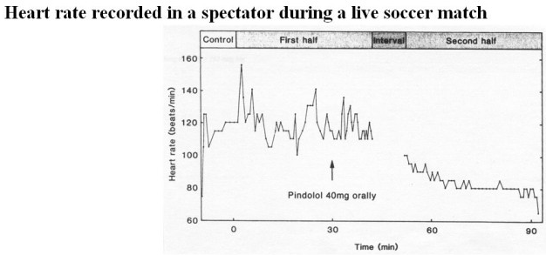

- given 40mg orally of Pindolol; partial beta agonist
- if adrenaline is high, it will have an antagonistic effect, will also have a bit of an agonist effect (will bring down heart rate but won’t bring it down as far as an antagonist would)

Another experiment:Propranolol and diazepam in somatic and psychic anxiety
Question: should somatic and psychic anxiety be treated with different drugs?

12 chronically anxious patients
- six had “psychic” anxiety
- six had “somatic” anxiety

Each patient received
- propranolol
- valium
- placebo

Each drug given for one week (random order)
Patients self-rate anxiety and preference for treatments

Results:
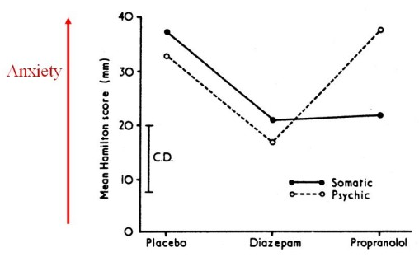

- diazepam reduced anxiety in both cases
- interesting finding: in the group that thought of themselves as “psychically” anxious, propronalol has no effect (acts in periphery to block sympathetic arousal so can expect this result)
- also, the effectiveness did not entirely match the preference; patients preferred diazepam by both “psychic” and “somatic” groups and propranolol was not preferred- the psychic group preferred the placebo to propranolol
- most effective drug is not always the one people prefer to take (not just in this study)

Another experiment: Oxprenolol (a β blocker) in the treatment of exam stress
Patients- student volunteers with exam anxiety

Methods:
- each student got oxprenolol or diazepam
- interviewed before, during and after the exam period
- each student recorded: his/her chance of passing the exam and the tension and anxiety (visual analogue scale; putting a number on subjective experience)
Results:
- self-rating before exam: rated about 70% anxiety, 3rd visit (end of exam): about 35%
- what is exam desperately lacking? A control! (was not one in the study)
How they did on their exam:
- those on β blocker tended to do the same or a bit better
- those on diazepam tended to do the same or worse

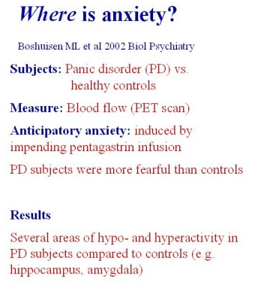

The above human brain imaging study and other studies both in humans and animals implicate the amygdala in anxiety and fear, within a broader network of brain areas.

Animal models of anxiety serve two purposes
- screen new drugs
- reveal brain mechanisms
Examples:
- elevated plus maze
- fear-potentiated startle response

Elevated plus maze
- relies on conflict animal has between his tendency to explore environment and fear of falling off
- rats prefer to stay mostly in the dark
- less anxiety= more time in open arms
- sedation (immobility) has little effect (score is %, overall time spent in open vs. closed so even if moving slower, will not affect %)
Results:
- given saline (control): spent about 10% of time in open
- given nicotine: increase in time spent in open
- not an ideal test; buspirone has no anxiolytic effect in this test

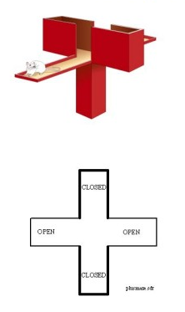

Another animal test: fear-potentiated startle response (more useful test because it can detect a wider range of compounds, including buspirone, and gives us an idea about brain mechanisms involved in anxiety)

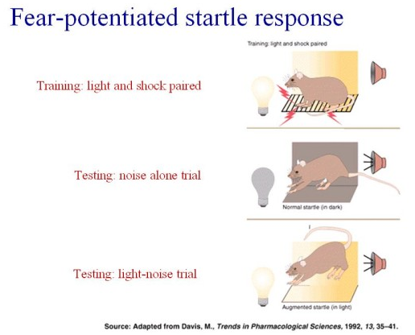

- based on idea: walking down a dark alley, you are fearful, a cat crosses your path, you jump up because you are startled
- training: light and shock paired- a light comes on the rat is shocked, so that the rat learns to the anxious when it sees the light
- testing: noise alone trial- a very loud noise is played and the animal is startled and jumps up a bit (how much the animal is startled is measure by the platform which has a strain gauge)
- testing: light-noise trial- conditioned response (associated light with foot shock… just shine light, make animal fearful/anxious); the mouse sees the light and hears the loud sound and is startled even more (jumps up more)
- difference between two conditions: the light i.e. effect of anxiety so want drug that makes the effect of the light less (taking away anxiety)

Can do various things with this animal model:
- can screen drugs
- can inject drugs into the brain and try to find out where they are working
- record from brain structures (e.g.: EEG)
- can also lesion different parts of brain to see if they are important in that behavioural response
Amygdala: very important
- contains many subnuclei
- important in fear conditioning

With the fear-potentiated startle response, people have traced the entire pathway:
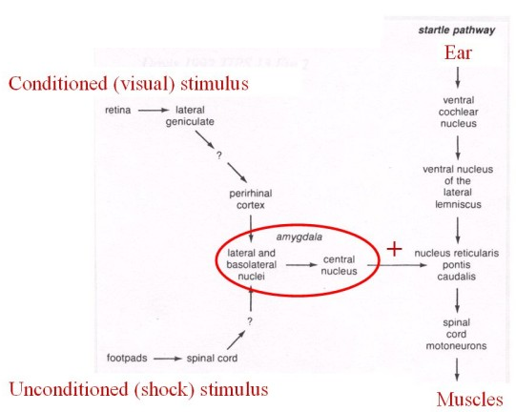
Amygdala potentiates the startle pathway if you are fearful.

Fear-potentiated startle response advantages:
- reveals brain mechanisms
- detects broad range of anxiolytics
- not only older drugs, but newer ones (e.g.: buspirone)

When we are anxious we have numerous symptoms mediated by different pathways.
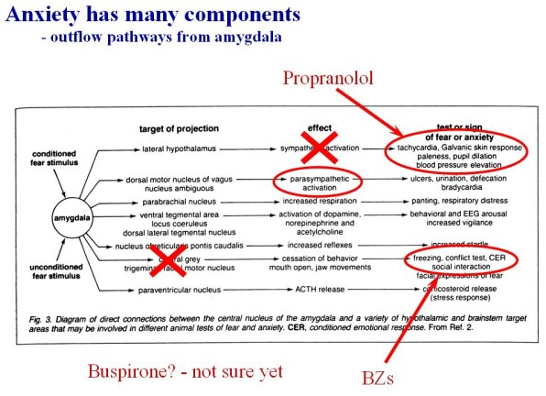

- anxiety is multi-faceted
- one drug does not block everything

Finally, remember:
- Currently available drugs are not a cure, they only treat the symptoms of anxiety.
- Drugs are not enough - you need psychological treatment as well.

